# Pathway model drawing challenge

## Quick start guide

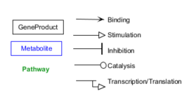PathVisio software is the pathway editor software for WikiPathways database. Pathway models consist of nodes and edges. Nodes are biological entities like genes, proteins or metabolites – but also pathways. Edges are interactions, e.g. binding, stimulation, inhibition, catalysis, conversion or transcription/translation. In PathVisio, it is recommended to use the MIM (molecular interaction maps) interactions which carry machine readable information about the exact biochemical nature of the interaction.

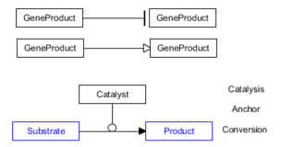

Simple pathways can look like this: One protein inhibits or stimulates another, another protein catalyzes a reaction which converts one metabolite into another.

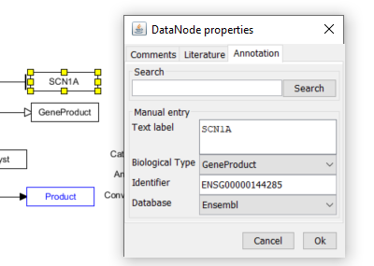Pathway nodes should be annotated with unique persistent identifiers from a biological database and have a human-readable label. You can either use the search field by typing in a gene or metabolite name and selecting the appropriate one in the search field or manually type in the name, identifier and select a database.

Interactions should be annotated with a reference from which source the information about this interaction is derived from PathVisio version 3 allows currently only PubMed identifiers for automatic information import. Other sources e.g. database information or textbooks can be added in the comments section. Generally, each pathway is a bit like a small graphical review, the information in the pathway should be backed up by experiments and/or publications.

## Drawing challenge

Create the following small pathway models for these biological statements:

1. Dopamine binds to dopamine receptor D1 (Gene = *DRD1*)
2. Alcohol dehydrogenase (ALDH1) catalyses the reaction of ethanol to acetaldehyde
3. Caffeine inhibits the purine receptor ADORA1, as stated in Froestl et al. 2012 (PMID 22886028)

Things get complicated when the original publications use different names than the todays common HGNC symbols. Wikipedia often has good records on old gene names. Also from literature, the exact mechanism molecular mechanism is often not known.

1. TNFRSF19 stimulates apoptosis via JNK1 and JNK2 (Reference: Guo et al. Biochem J. 2015. PubMed 26438880.)

Kinases phosphorylate proteins in order to regulate their activity. In PathVisio, you can indicate a change of phosphorylation “state” by rightclick on a gene product node and select “Add state”. This can also be used to indicate other types of protein modifications like methylation, acetylation or ubiquitination. In this specific reaction, the native protein acts as substrate, and the modified protein as product linked by a chemical conversion MIM interaction.

1. After binding of FGF1 to FGFR4, FGFR4 phosphorylates FRS2.

Many proteins form complexes with other proteins in order to fulfil their function. To draw a complex in PathVisio, select all the nodes that are part of it, right click and select “Create complex” – or use CTRL – P. The complex portal from EBI <https://www.ebi.ac.uk/complexportal/home> has a lot of information on protein complexes and provides IDs for complexes. In PathVisio you can use the “?” or “Unknown” datanode to create a new, and select “Complex” in the Biological Type selection. You can add the identifier of the complex manually, unfortunately Complex Portal is not yet available in the database selection (but will be in the next version).

1. SMARCA5 and BAZ2A form the NoRC chromatin remodeling complex.

When you finished with the drawing challenges, feel free to think about your own scientific work – do you have any pictures of molecular models that you would like to translate into a machine readable pathway?